
Department of CSE

B.Tech. CSE Trimester -5

Roll Number : 2520030299
Name : Shaila banu

Cloud Infrastructure and Services
25CS2206E

LAB RECORD
2026

Experiment -2.2

AIM: To create an MFA on a new AWS account

Description: Multi-Factor Authentication (MFA) was enabled on the AWS root account using the Google Authenticator mobile application. MFA provides an additional layer of security by requiring a time-based 6-digit verification code along with the AWS account password during login.

Steps:
- Installed and opened the Google Authenticator application on the mobile phone.
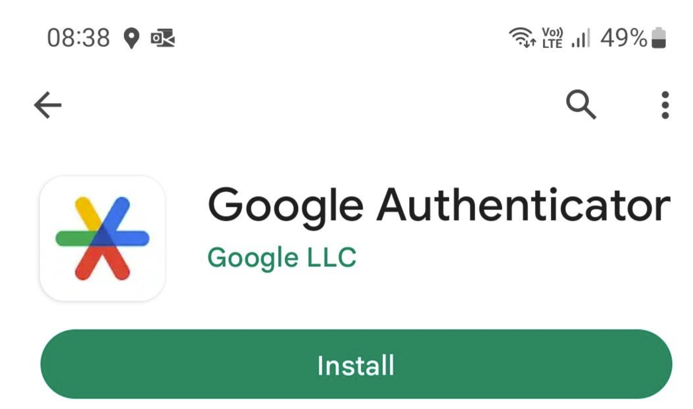
- Logged in to the AWS Management Console using the root user credentials.
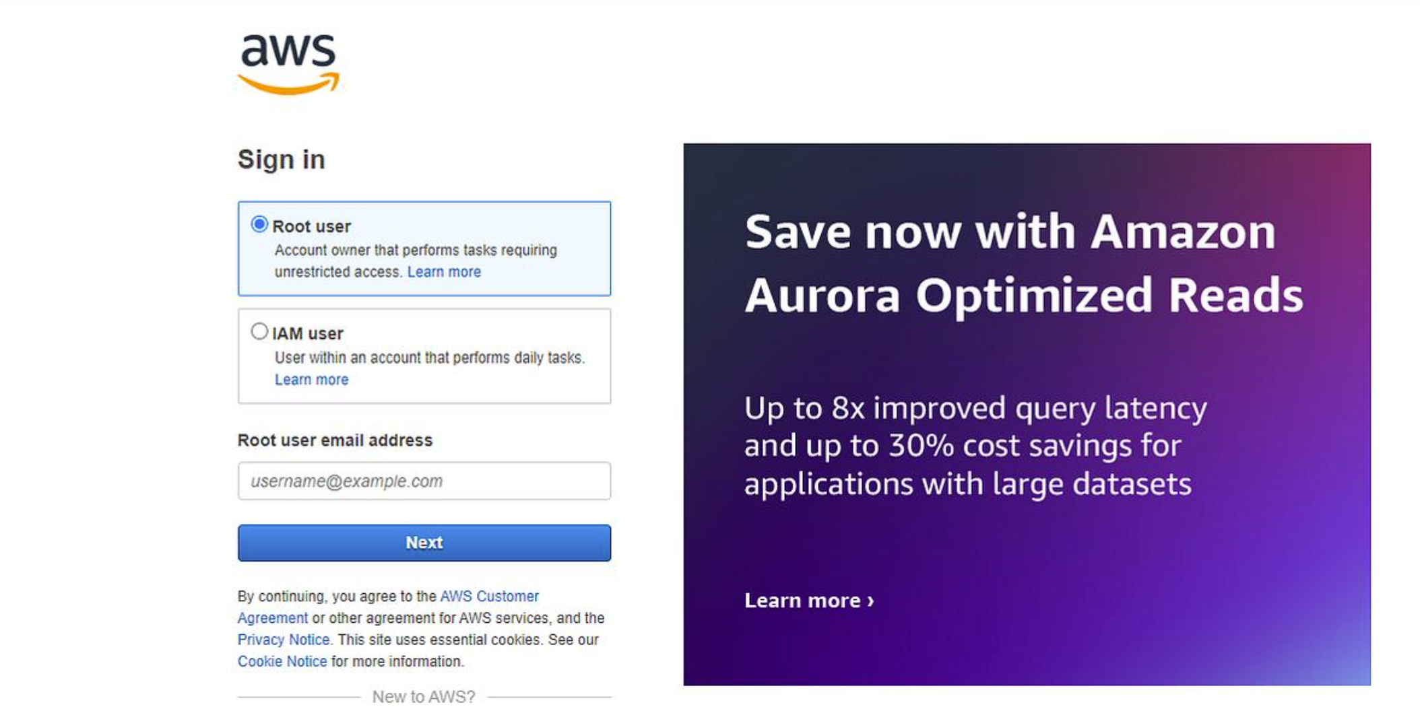
- Clicked the account name in the top-right corner and selected Security credentials.
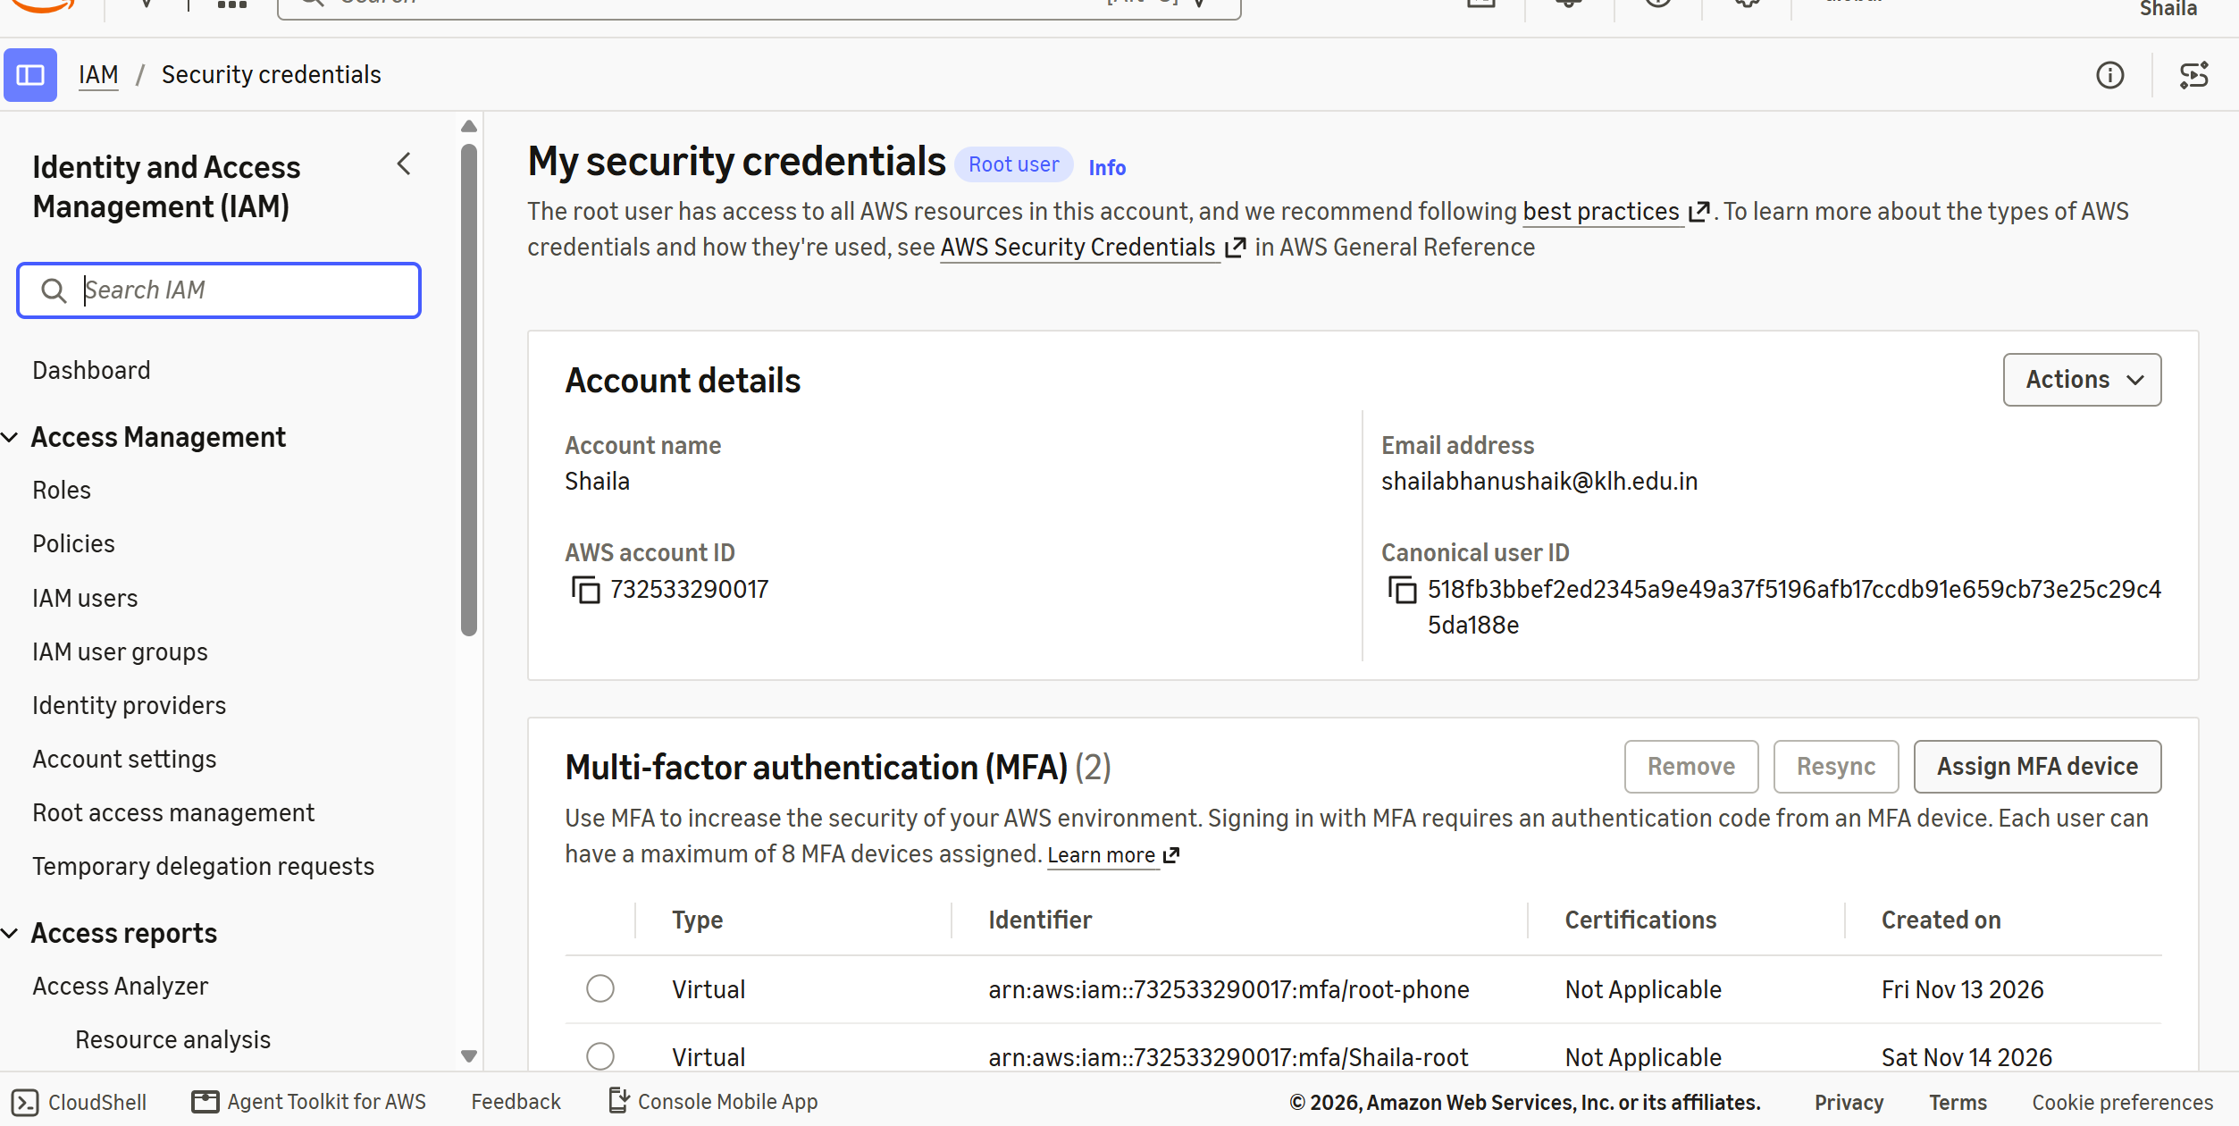
- Navigated to the Multi-Factor Authentication (MFA) section.
- Clicked Assign MFA device.
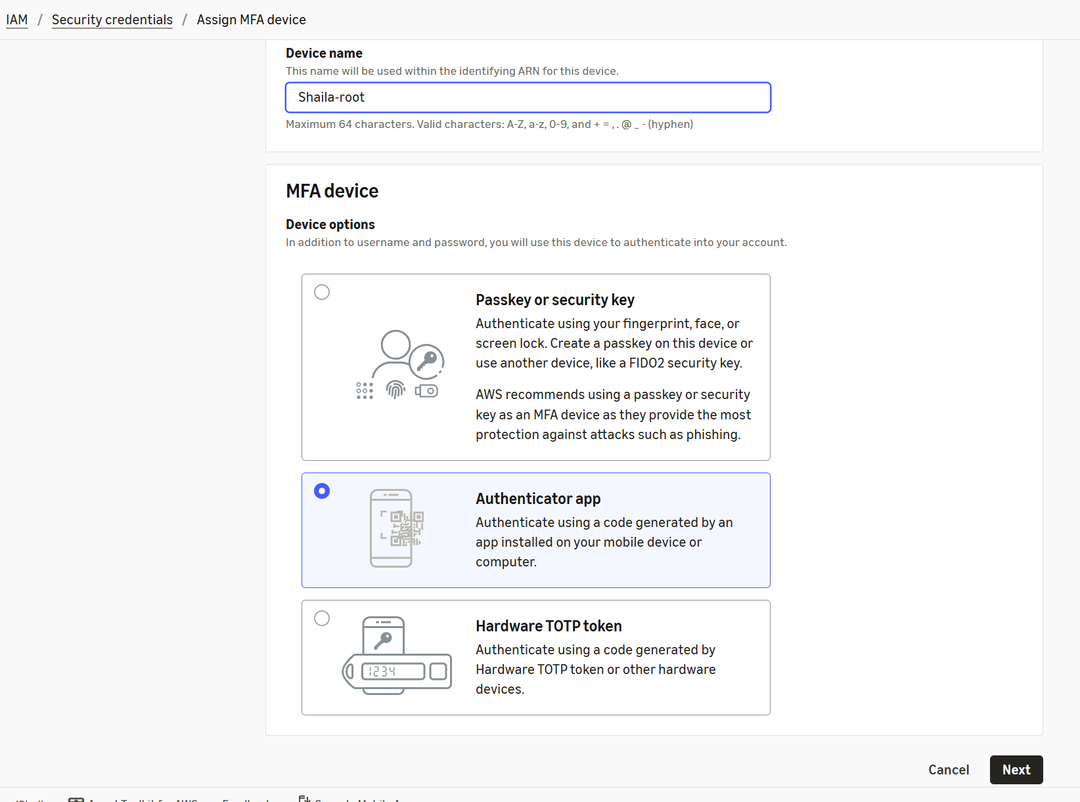
- Entered the device name as root-phone.
- Selected Authenticator app and clicked Next.
- Scanned the QR code displayed on the AWS console using Google Authenticator.
- Entered the first 6-digit verification code in MFA code 1.
- Waited for the code to change and entered the second verification code in MFA code 2.
- Clicked Add MFA to complete the setup.
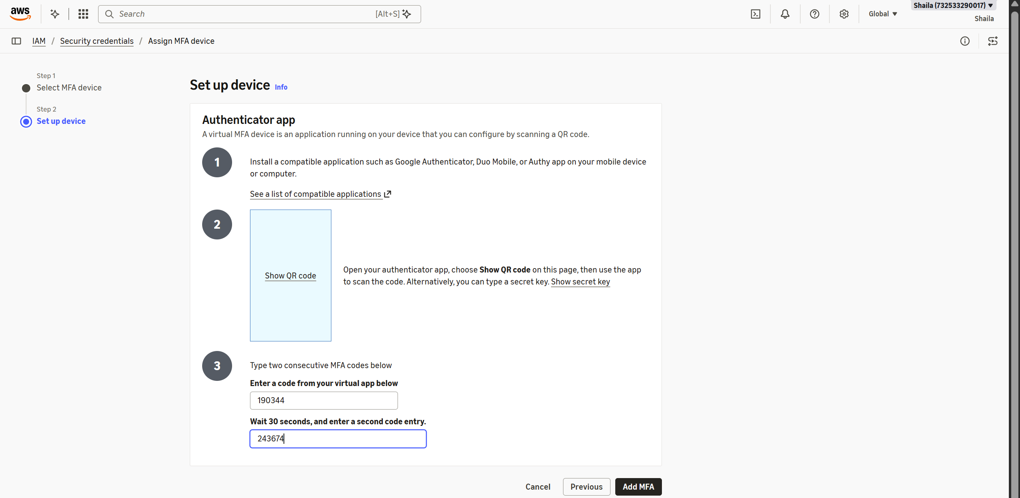
- Verified that the MFA device was successfully registered with the AWS root account.
- 

